OD2-Unit3 知识清单
上课内容 | Unit3 What Is Our World Made Of? | 学习目标
单词1 | 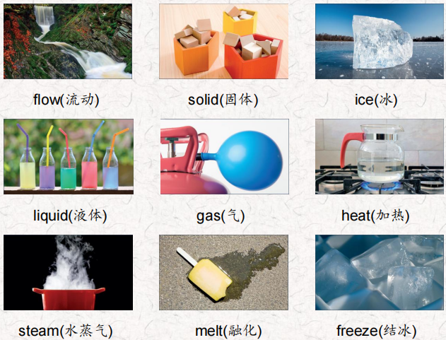 | 会听、会说、会读、会默写
短语 | be made of着重指从制成品能够看得出原材料；  be made from着重指从制品不能看出原材料。  think of 想出 | 短语会造句
阅读技巧 | Cause and effect tells how one event makes another event happen. A cause is why something happens. The effect is what happens after the cause因果关系告诉我们一个事件如何导致另一个事件的发生。cause是指某事发生的原因。结果是在原因之后发生的
重点句型 | What is our World made of?我们的世界是由什么构成的?  Everything in our world comes in three different states: solid, liquid, or gas.世界上所有的东西都有三种不同的状态:固体、液体和气体。  Some solids are hard, and some solids are soft. 有些固体是硬的，有些固体是软的。  Trees and feathers are solids. 树木和羽毛都是固体。  Can you think of other kinds of liquid?你能想到其他种类的液体吗?  Things can change from one state to another when we make them hot or cold.当我们使物体变热或变冷时，它们可以从一种状态改变到另一种状态。  When we make water very cold, it freezes and changes to ice.当我们把水弄得很冷的时候，它就会结冰，变成冰。  When ice or snow heats up, it melts and changes back to water.当冰或雪加热时，它融化并变回水。  When we heat water, it boils and changes to steam.当我们加热水时，它沸腾并变成蒸汽。  What's the cause of the snow melting? 雪融化的原因是什么?  What's the effect?效果如何?
听力 | 听力词汇：  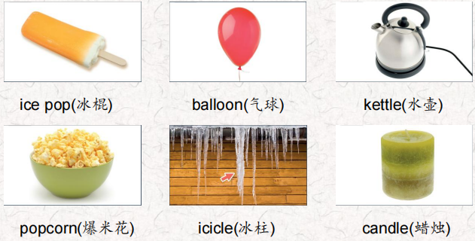  son 儿子  听力原文：  Let's talk about how solids, liquids and gases can change. l have some things we see every day. See if you can guess what they are.  One.  A lot of people like this very much lt was a liquid but now it's a solid. How do we make this thing? We freeze it to make it very cold so it changes to a solid. You should eat it fast on a hot day!  Two.  This thing is a solid, and small and soft. But when we put some gas in it, it gets big and is like a ball. We shouldn't add too much gas to it or it can pop! We often see these at parties.  Three.  This is a container and we heat water in it. When the water is hot, it changes from a liquid to a gas and we see steam. If we heat it for a long time, all the water changes to steam. Four.  This is a solid. But if we make it hot on top, it melts, the top changes to a liquid, and this thing gets short. When it gets cold again, the liquid part changes back to a solid.  Five.  This is in a very cold place. When it gets very, very cold on a house, the water dripping down on the side of the house freezes, and changes from a liquid to a solid. When it gets warm this melts and changes to water again. Six.  This is a solid. When we make it hot, it doesn't change to a liquid or gas. It stays a solid and gets big... Look! They were very small, and now they're big. Mmm. It smells good! I'm hungry. | 每天听+跟读
口语 | Accepting a Request接受请求  Please pass the juice.请把果汁递给我。  Sure. Here you go.好的。给你。  Thanks.谢谢。  You're welcome. 不客气
复述课文复述 | 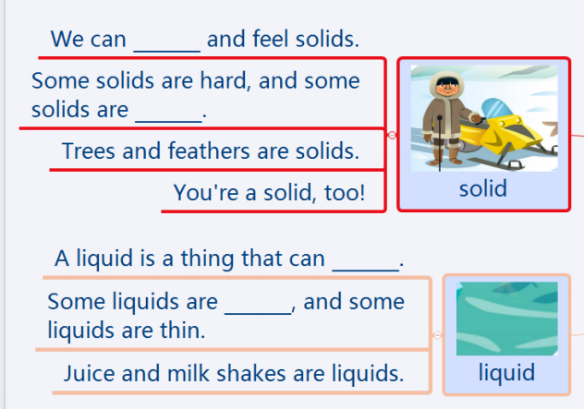  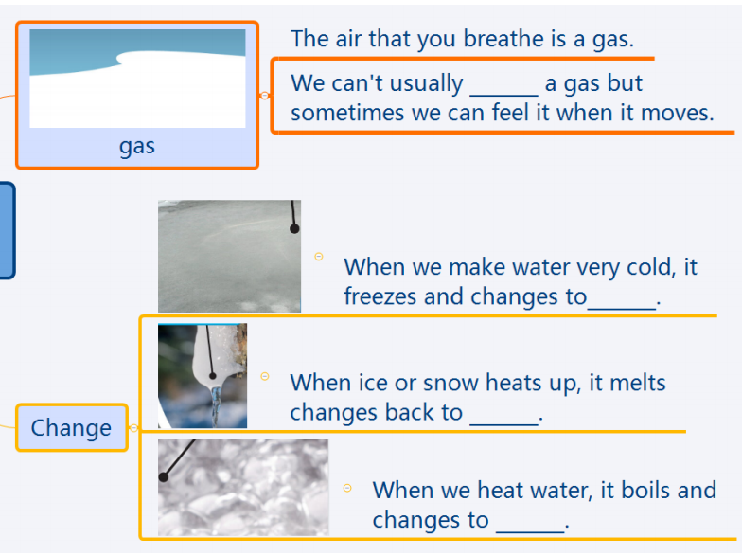 | 根据关键字提示复述课文复述
语法 | 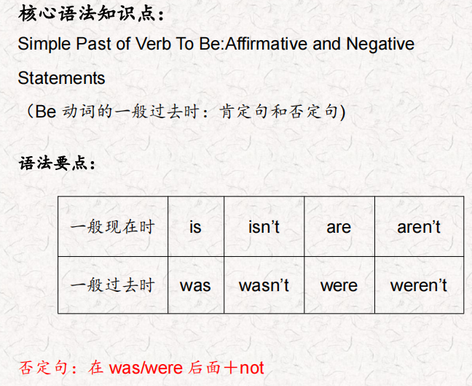
写作 | 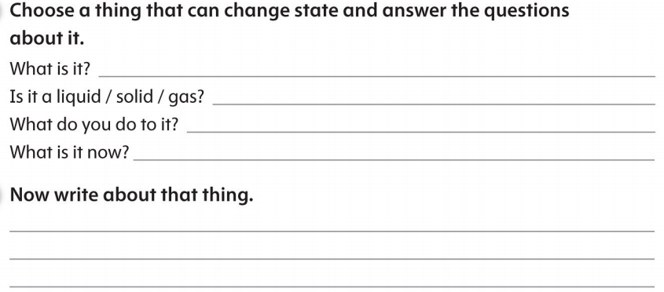 | 仿写

